**SoLibrary Project Report**

# **Project Background**

USYD established the Academic Electronic Text and Image Service (SETIS) in 1996. SETIS was the first service of its kind in Australia and has developed as a national platform for innovative electronic publishing and digital library conversion projects. By the early 2000s, the library's website had become the primary means of accessing library resources and services. USYD's library website offers a rich variety of resources, including rare books, electronic publications, and databases.

**Figure 1**

*Current USYD Library UI*

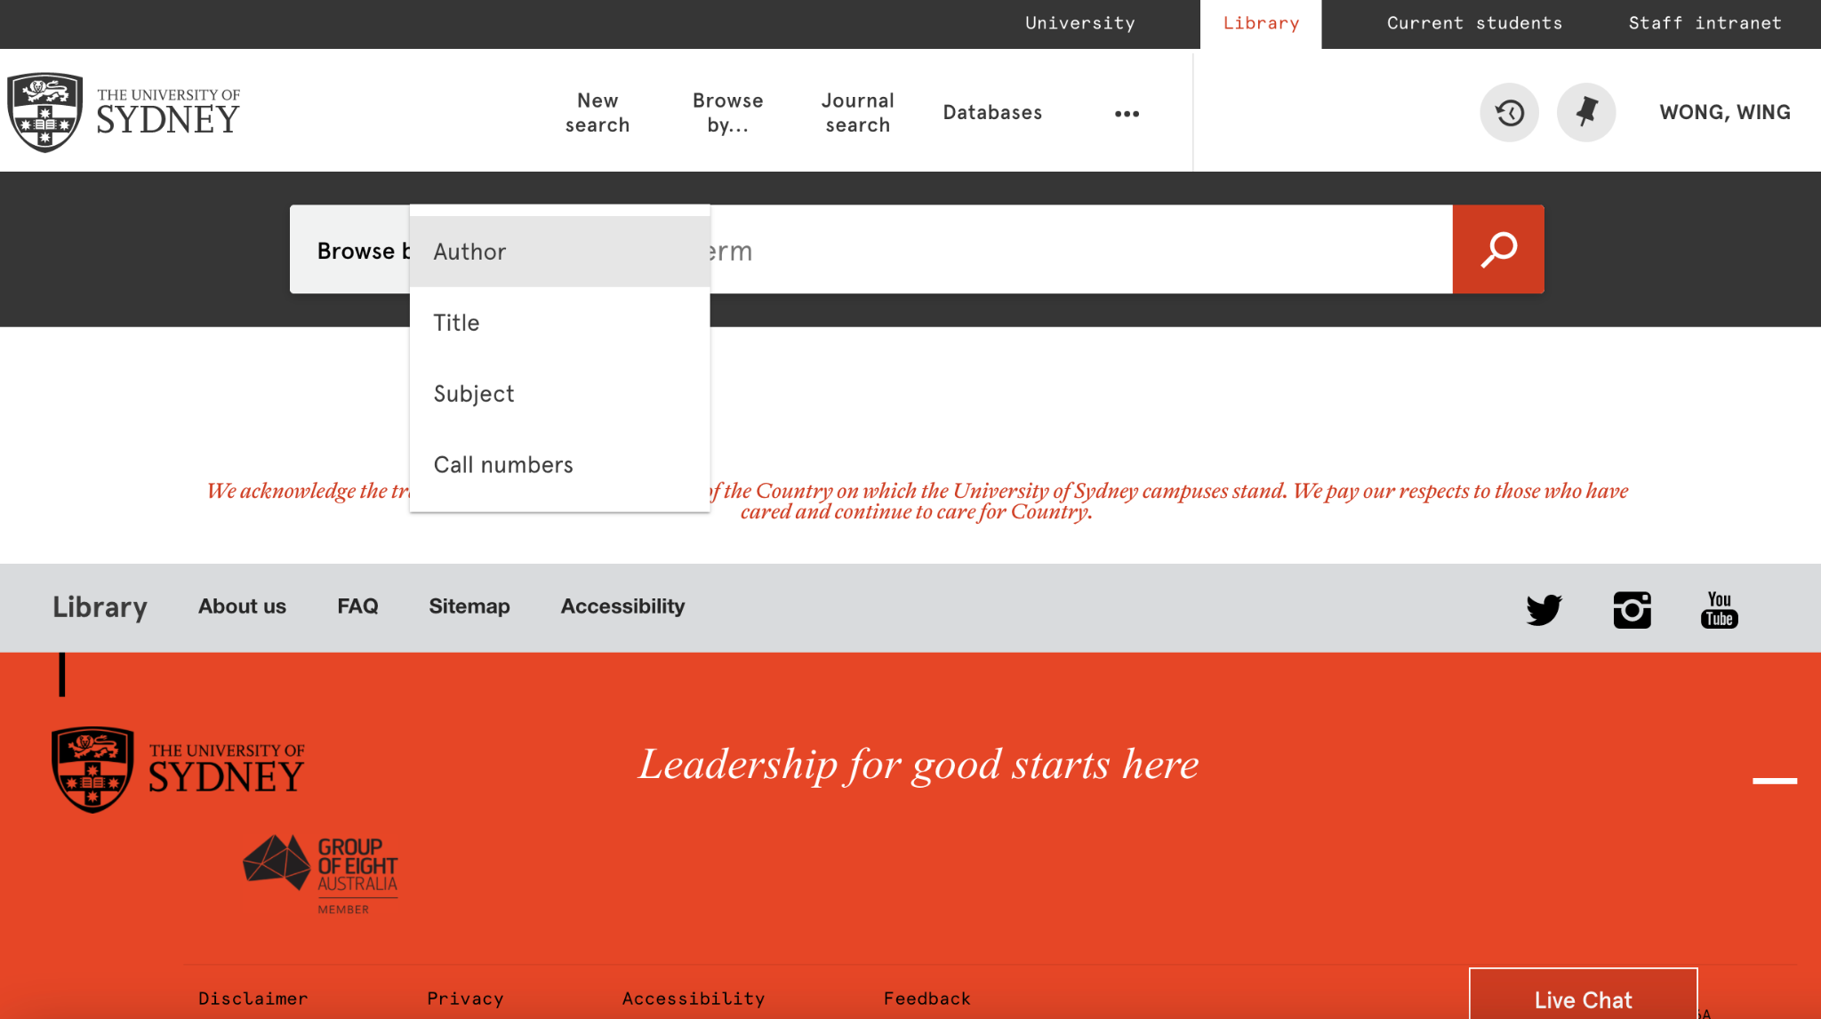

Within the current digital library system of USYD, its major function is researching the articles. For the research process, students need to know the exact title of the article, or the name of the author, or the call number of the article to screen out the accurate articles. It needs students to have a great knowledge of the exact article they need to find. This is the passive process of people to retrieve information, as students have to look up by themselves and research one by one. This would frustrate students, as most of the time, students have no sense of direction of what articles they need to read, they are new to the area of different subjects. Therefore, it cannot cultivate the interest of studying for students and cannot motivate the student to read.

**Figure 2**

*Percentage of student using researching tools*

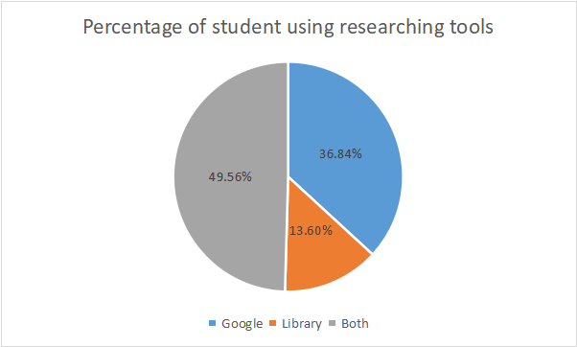

We conducted an online survey to investigate the current situation of how students do research when doing homework. A total of 228 students filled out the questionnaire, and the results showed that 84 students used Google, 31 students used the school's library website, and 113 students used both Google and the library website.

From the user perspective, students tend to use Google to research articles rather than the school library, which shows the current online library is less efficient. In addition, students approach the required articles which are assigned by teachers within the Canvas. Students do not need to approach the readings within the digital library system. This also reduces the frequency of utilization of the online library. However, within the Canvas, students need to click each week module for each course separately to approach the readings that are assigned by the teacher, which is not inconvenient to have readings placed on dozens of websites. As students have to switch many pages in finishing all readings for every week, it would reduce students’ enthusiasm to read.

For the current online library system, the interaction is more likely between the system and students. It ignores the communications between students and teachers, and the peer-to-peer communication, which is a good way to improve the learning quality of students. Especially, due to the COVID-19 pandemic, students have a high quality demand for remote learning. Under the travel restrictions and the lockdowns, students cannot communicate with each other face to face within the campus, and then they cannot have the opportunity to know what their classmates are doing, what books they are reading, what extra topics they are focusing on. The system did not deal with the problem of declining students' enthusiasm which was caused by online teaching.

# **Problem Statement**

Nowadays, the library system of USYD is not supportive enough for students’ learning demand. An online library is supposed to provide an effective and efficient approach for students to do research as well as communicate with peers and professors. However, the search engine of the school library cannot meet this standard. Students are facing the problem of “infobesity” and having to look up for articles by themselves.

Firstly, There are thousands of resources available to students, and the number of these options is overwhelming (Bielefeld, 2019).That’s so much content, it would take the average person their whole life to read (Trading Central, 2022). It’s also a huge challenge for students to identify useful and qualified information with their critical thinking (Bielefeld, 2019). Too much information and articles may discourage students from absorbing and learning knowledge. For example, many junior students are at the stage of starting to know a specific area of their courses or majors, they don't have much knowledge and information about PROFESSIONAL keywords due to lack of understanding of this new subject. When they use the traditional online library of USYD, they don't even know what KEYWORDS they should input to get relevant articles more accurately. Besides, loads of articles are presented to them, it will be a waste of time to figure out what specific articles they really need and what their peers are reading. For the teaching teams, they might have the same issues in searching for what students are interested in, even though they are pro, always knowing what they need to search for. Traditional “looking up” way is a bit time-consuming and a headache.

Secondly, when students meet any issues associated with reading articles, there is no place for them to leave comments directly, they have to email teachers to figure out their problems, the back and forth will cost days.

Thirdly, the required readings of different courses in canvas are set in seperate pages, students have to look up for them in different pages of their courses one by one, that’s of low efficiency and effectiveness. There’s no uniform webpage for students to check and read all the required readings set by teachers.

# **User Personas**

**User 1: Students**

**Name:** Lily Khun

**Identity:** First year master of commerce (Coursework) students



**User Backgrounds:**

Lily is a first year master of commerce student. Lily is from Cambodia and she is the first overseas student in their family. She wants to learn about international commerce to help her family's fruit trading company run better. Since English is not Lily's native language, it is difficult for her to study. Also, she is not very proficient at using the school's library website, so it is difficult for her to find articles that meet the needs of her courses. Lily needs a more friendly library system to help her access more relevant materials.

**Motivation:**

* Help family to expand family business.
* Want to improve her English skills.
* Improve the ability of self-learning.
* Expanding horizons.

**Goals:**

* To gain more commerce and management knowledge and skills to help family business.
* Expanding family business to a multinational company.
* Becoming a lifetime learner.

**Pain Points:**

* Do not have enough time to read all the articles recommended by teachers, hoping to learn the main points from the articles.
* Do not have effective way to exchange opinions of course readings with friends or schoolmates
* Have some reading barriers to understand every words of every articles as English is not her first language
* Having difficulty finding high quality articles to support assignments.
* Cannot make sure to understand all content of the articles.
* Not able to get access to all articles related to or required by subjects.
* Lack of motivation to do research and readings, feel boring to do them.
* Suffering from readings since reading is the only section that doesn’t have instructors or helpers.

**User 2: Teachers**

**Name:** Andy Zhang

**Identity:** Professor of Anthropology

**User Background:**

Andy has been teaching Anthropology for 18 years. He studies the relationship between politics and human rights , as well as the impact of changes in social systems on human beings. He is required to release the articles to students every week to help students to master the knowledge they learned within the week, and leads them to think deeply about the knowledge they learned. He is also willing to solve students’ puzzles in regards to the articles he released.

**Motivation:**

* To attract more students to study anthropology and enjoy their study journey of anthropology.
* Leading anthropology students have more deep thinking of anthropology, which provides them more perspectives to deal with human issues and can help to broaden their horizons.
* To help students develop a sense of self learning.

**Goals:**

* Help students to study this subject easily and happily, as this subject needs to have massive reading.
* Have quick access to the latest news and articles related to Anthropology.
* Effectively collect the reading feedbacks from students, including the problems that they face in reading and writing their assignments
* Improve students’ interest in Anthropology.

**Pain Points:**

* Having difficulty finding more attractive and relative articles for students.
* Not exactly knowing whether students have deep thinking related to the articles required them to do.
* For this subject, some essays that students wrote were less relevant to the topic, and the articles provided were less used by students.
* Students seem to have very low motivation to research and read actively.

## 

# 

# **A system narrative/story board**

**User Group 1: Student**

Xiao Zhou logs into SoLibrary with her USYD Uni Key to study for her INFS 5002. After logging in, the home page of SoLibrary shows some bubbles, which indicates numbers of “HOT” articles that may be related to her major and units of study. Figure 1 shows the inspiration of the UI. In Figure 1, the bigger the bubble is, the more popular(more views, clicks, comments and recommendations) this topic is.

**Figure 3**

*Article Bubble(lThiset articles surround you, let relevant articles find you)*

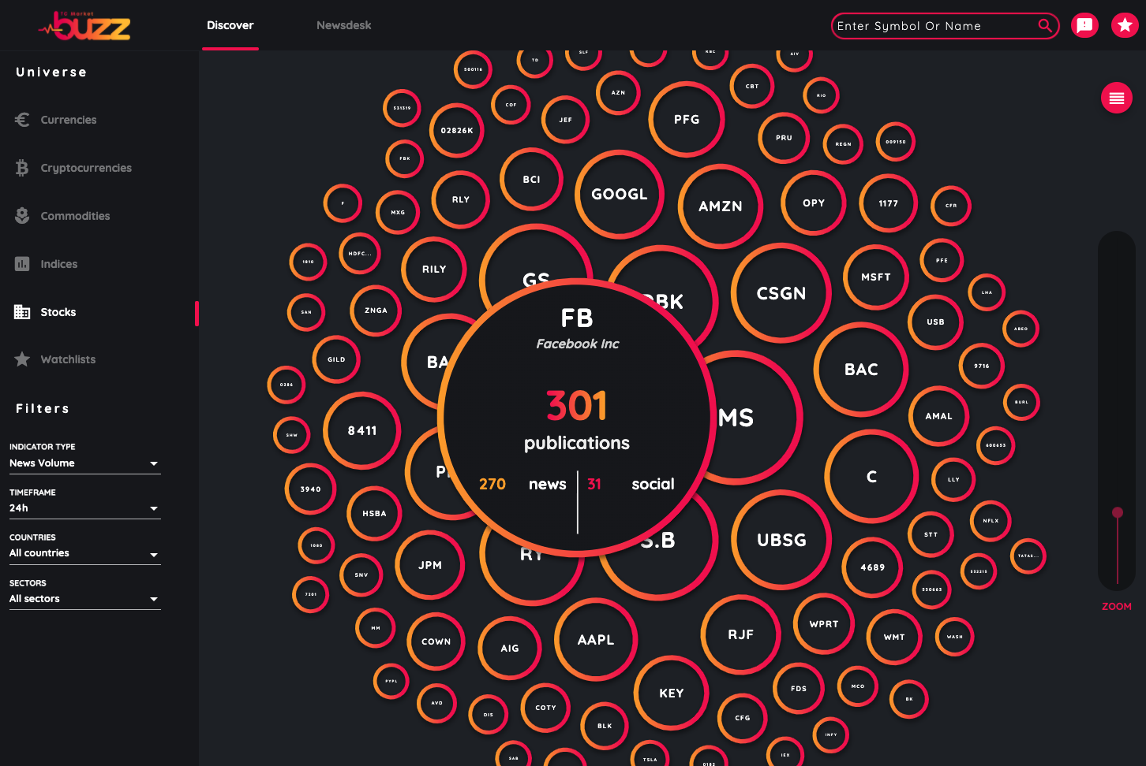

Note. Copyright 2022 by Trading Central.

She clicks on the bubble of INFS 5002, which is the biggest bubble on her screen. This means that a lot of articles that are related to INFS 5002 are clicked, viewed, commented and recommended by students and teachers. This is because there is an essay assignment for QBUS 5002 due next week, so students are doing research and reading for their essay. Then the page jumps to a list of articles that are read the most by the students in the same study area. She finds one title of those books, which looks interesting and may relate to her assignment due next week. She clicks into that article and starts to read and finds a few references that are very useful to develop her problem statement for the assignment.

Then she gets back to the home page. On the left side of the screen, there is a menu bar with a button called “My Courses”, which shows all units of study that Xiao Zhou enrolled for this semester. Then she clicks on the BUSS 5221 and the page jumps to a list of readings prepared by the unit coordinator. Then she starts to read the required articles. After finishing the reading, she has some questions about the content. She scrolls to the bottom of the article, there is a comment area. She sees some comments by some students and teachers that help her understand the content of the article better. She also raises one more question on the comment and selects BUSS 5221 as the course that related to this question. After few hours, she logs back into the SoLibrary to check if anyone answered her question. She sees there are two students trying to help her with her question, and the workshop facilitator of BUSS 5221 also answers this question. Now she gets a better understanding of the knowledge for this week. She also see there are 3 titles of articles under this page, which are pushed by the system of SoLibrary, it is called “Students read this article are also reading these:” Xiao Zhou thinks: “There are some students studying so hard to read extra, maybe I need to read these articles as well to help me get better understanding.”

**User Group 2: The Teaching Team**

Herry Brooks is a professor of philosophy. Each week, he logs into SoLibrary and puts in some reading for every course he’s lecturing. When professor Brooks logs into the system, he is able to see every course that he is lecturing as a list. Then he goes into each course and puts all the reading that he wants his student to read for next week’s course topic. Articles are divided into three categories, the required readings, the recommended readings and the supplementary readings.These readings are all from the USYD library. He also posts some questions that he wants students to think about after reading the articles. After she finishes putting the readings for next week. She goes to the page called “Students are reading”. In this page, he could see a list of articles that are read most by his student in corresponding courses. Some of these articles have a red dot on the title. This means students have questions regarding this article for his course. Then he goes into these articles and looks into the comment section and answers the questions for his students. From the list of articles his students are reading, he finds few of these articles do not relate to his course topic, he realises that some of his students may be doing research in a wrong direction. He then goes to canvas and posts an announcement to kindly give some hints about the research direction. He also realised that maybe there are some important issues that are not covered or understood well by students, so he goes back and tries to redevelop the course content to improve.

**Data Specification and integration**

**Figure 4**

*DFD-Student Search Readings*

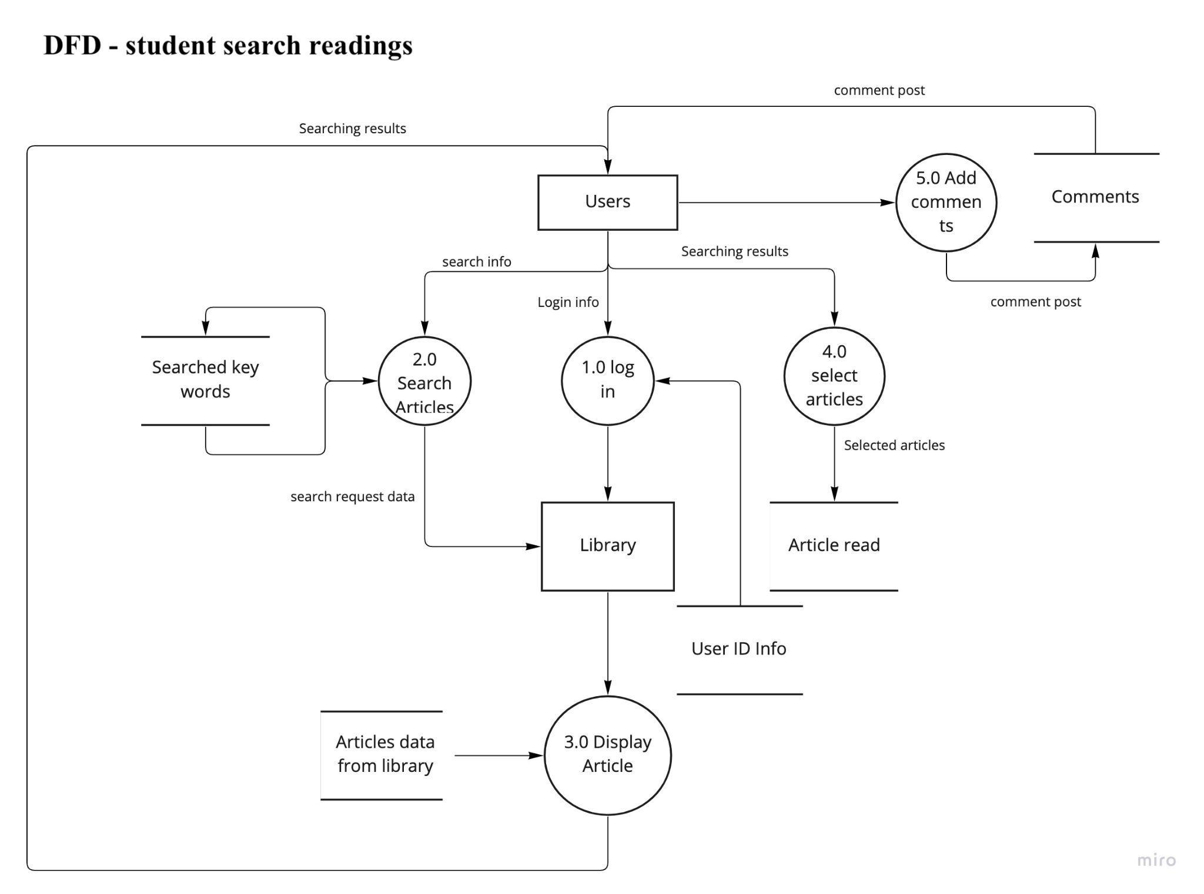

As it shows in Figure 4, students will need to login with username and password, which are stored in the User ID Info database. After logging in, students could input keywords to search for readings. The keywords will be stored into a database so that the Solibrary system could further analyze the search rate of the keywords to define if they are top searched keywords. Library system will pull related articles from the existing articles database based on the searched keywords and display them to students. After students read the articles, the system will capture the data of read articles and store them into a database of article read. These read articles will be further analyzed to push other students. If students have any comments, they can post comments after they read the articles, and the comments data will be stored into a database.

**Figure 5**

*DFD-Push Daily Reading*

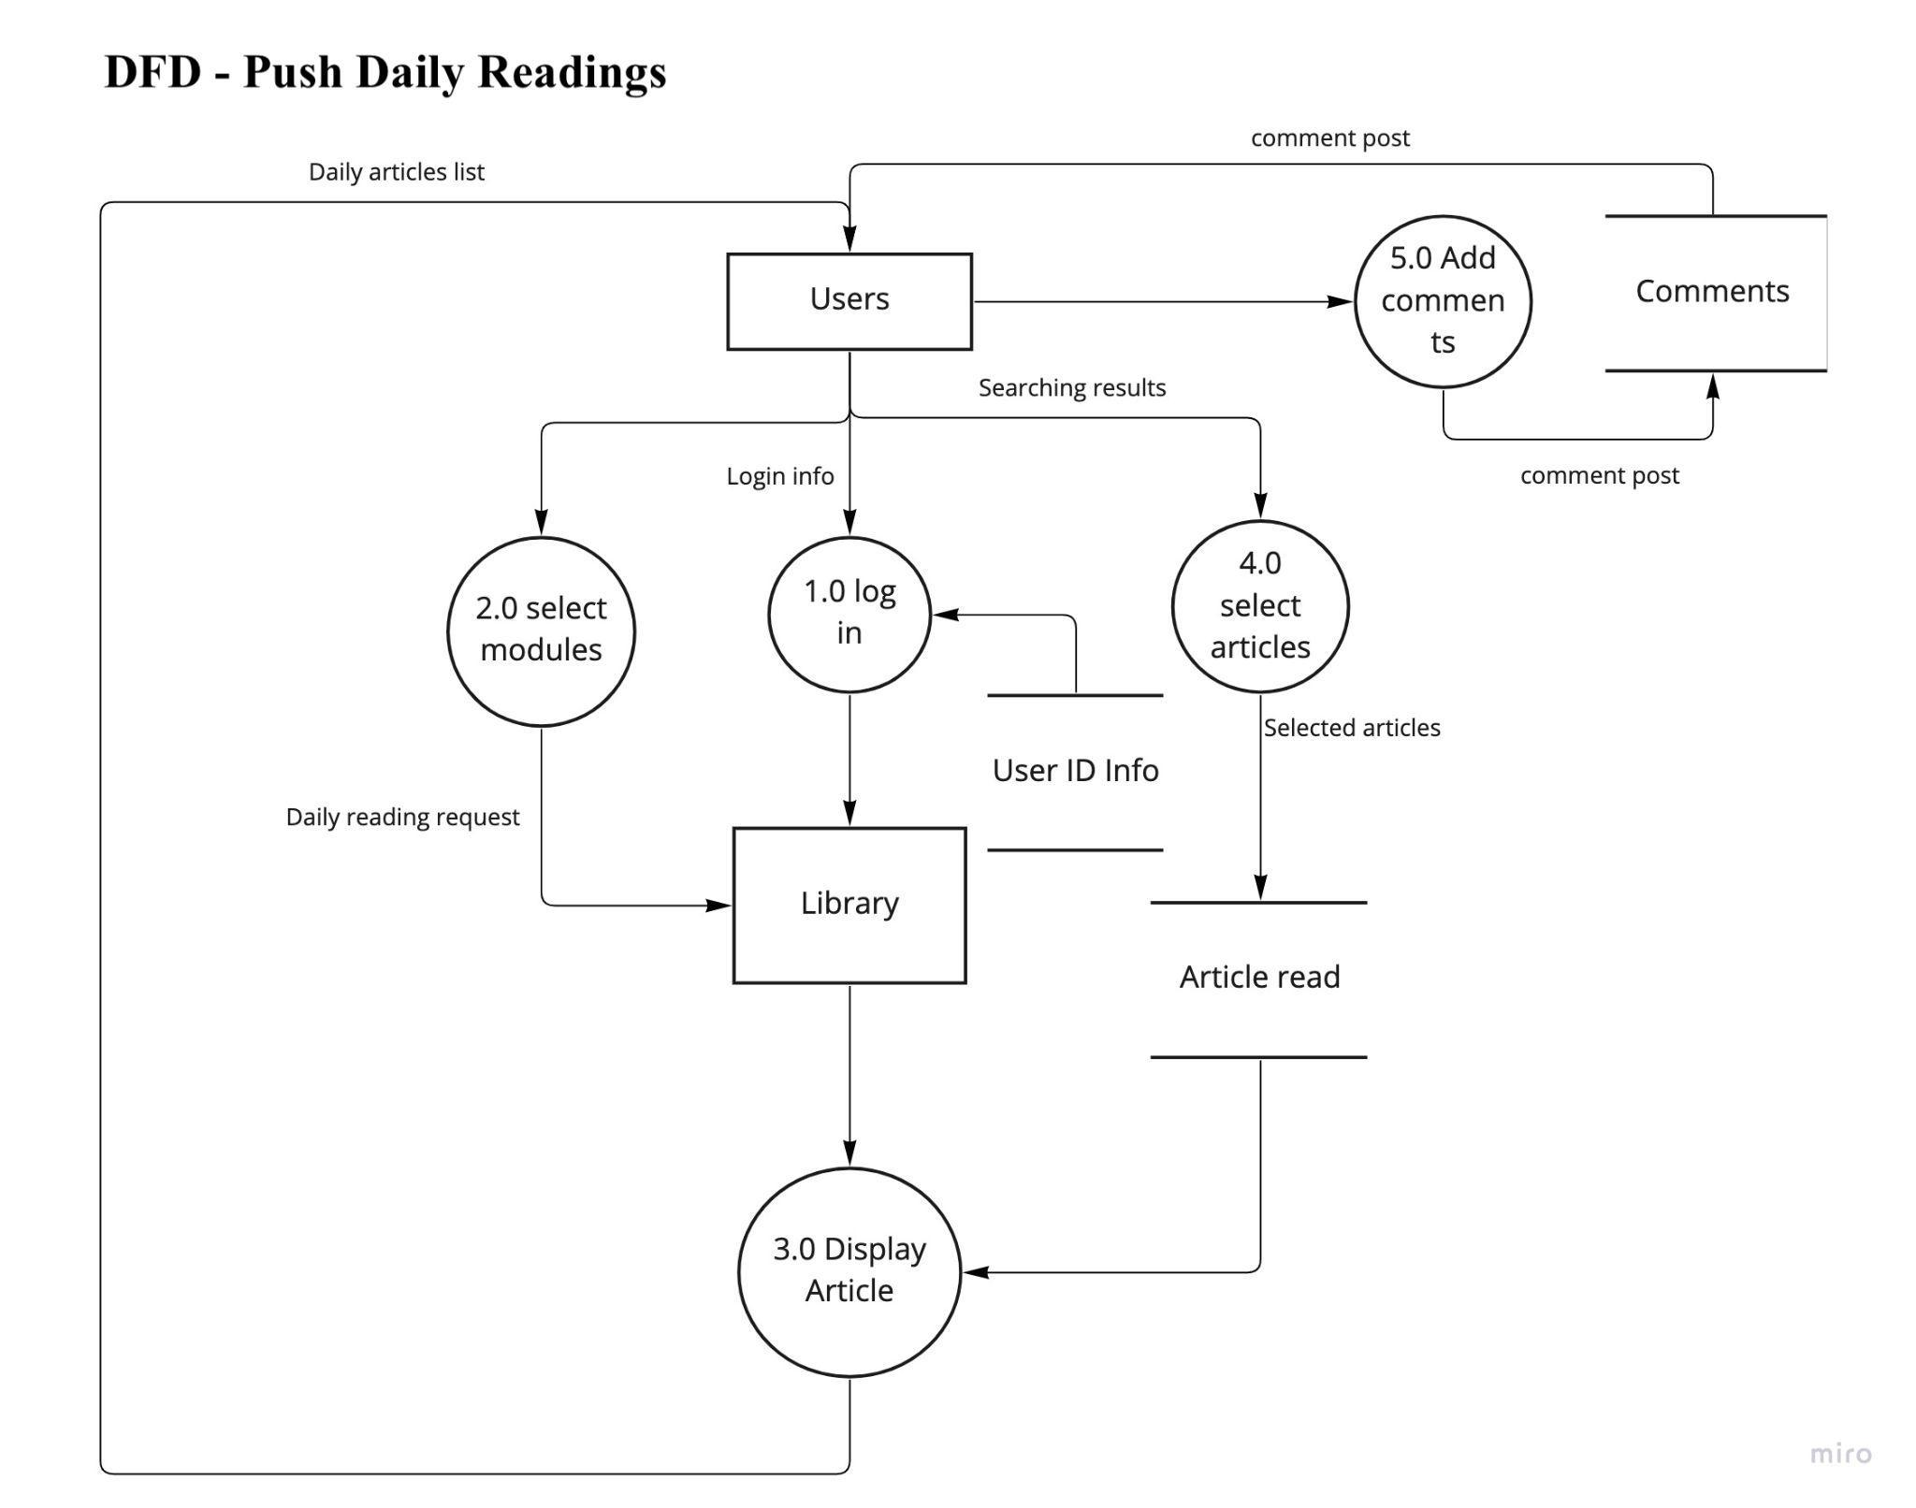

As described above, the articles read by students will be further analyzed and stored in the “Article read” database. Students who want to know which articles their classmates are reading can log into Solibrary and go to the “Daily Reading” Module as it is shown in Figure 5. The system will pull articles that are read by the users’ peers from the “Article read” database. Articles in this database will be ranked by the number of views.

**Figure 6**

*DFD-My Course Assigned Readings*

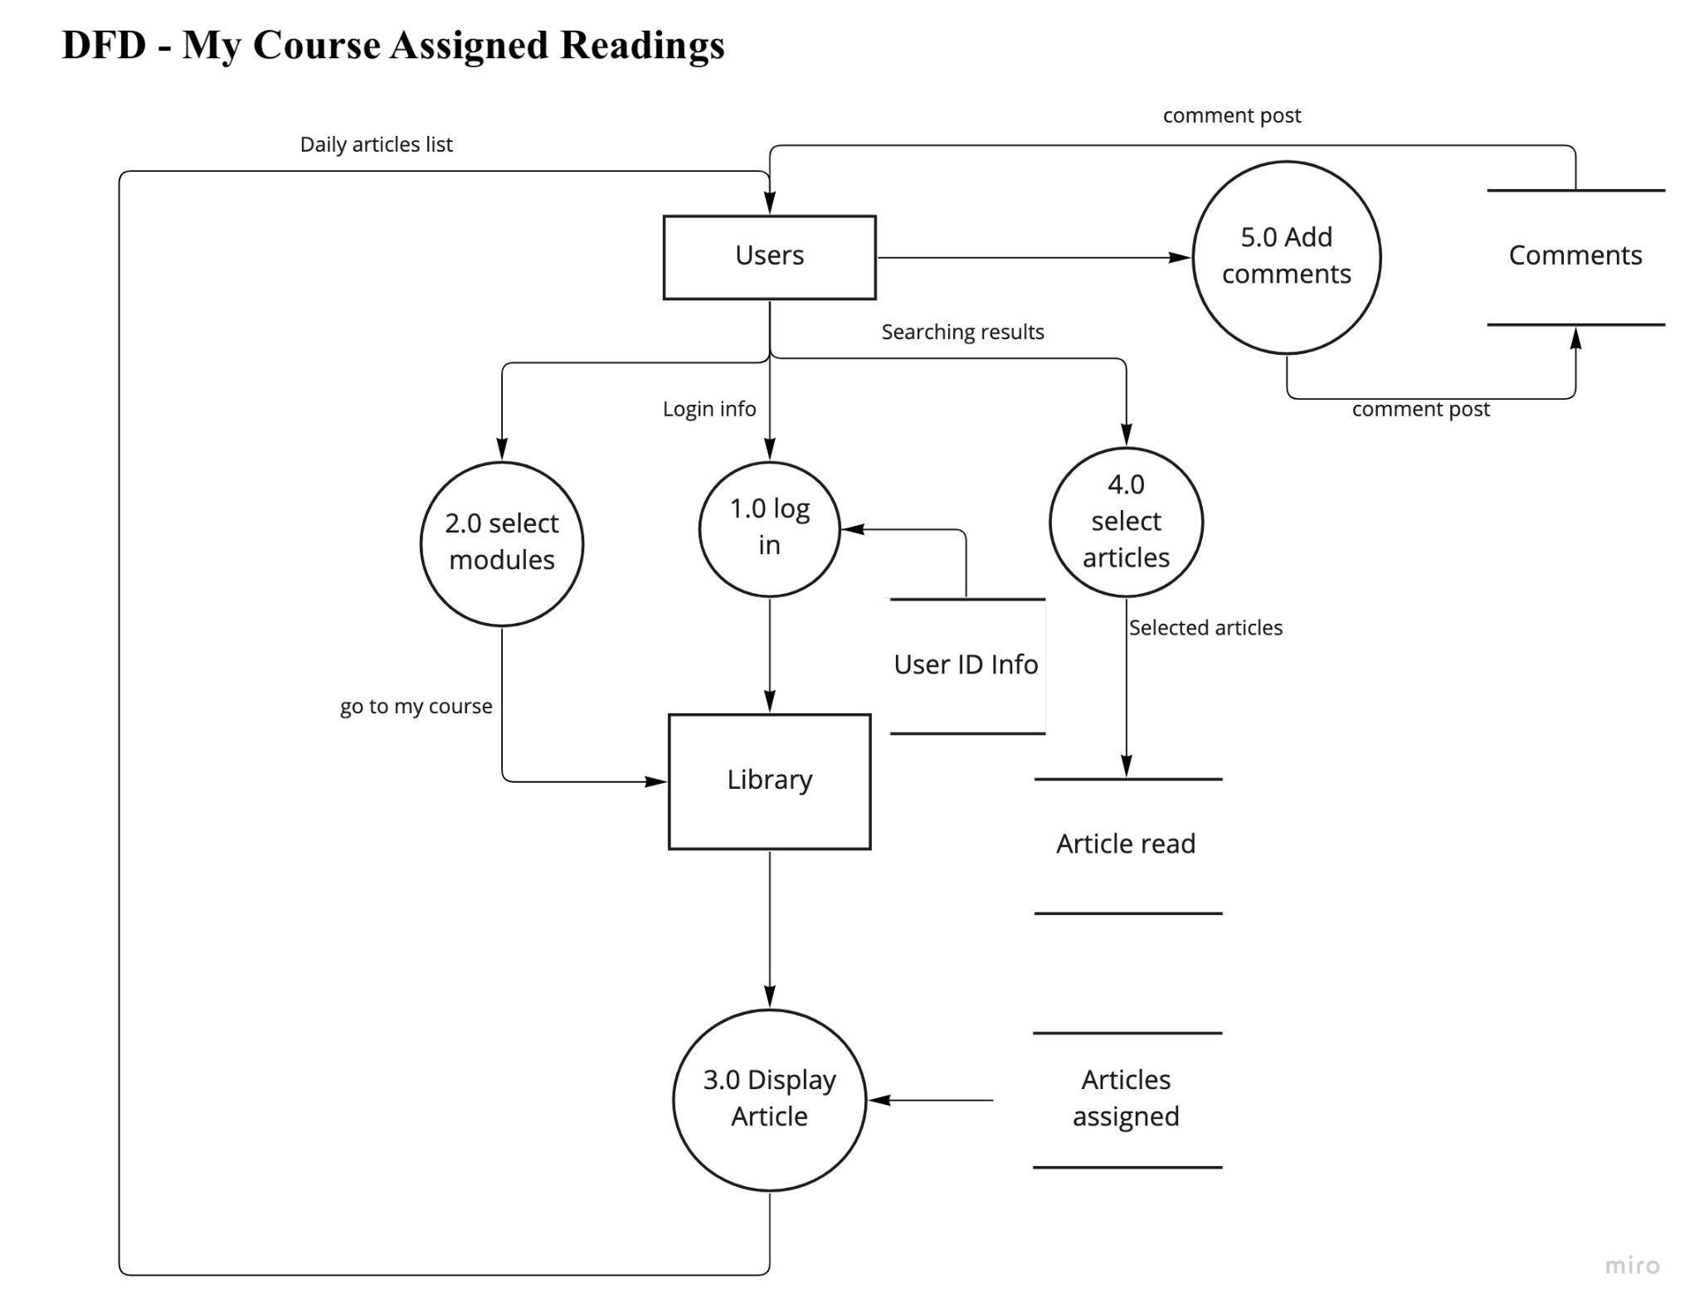

As shown in Figure 6, students need to use the Solibrary system to reading articles assigned by the teaching team. After logging in and selecting the “My Course” module, the system will pull the articles assigned by the teaching team from the “Articles assigned” database. If students read the articles, these articles will also be stored in the “Article read” database for “Daily Readings”. Comments function are still the same.

**Figure 7**

*DFD-Teaching Team Assigning Readings*

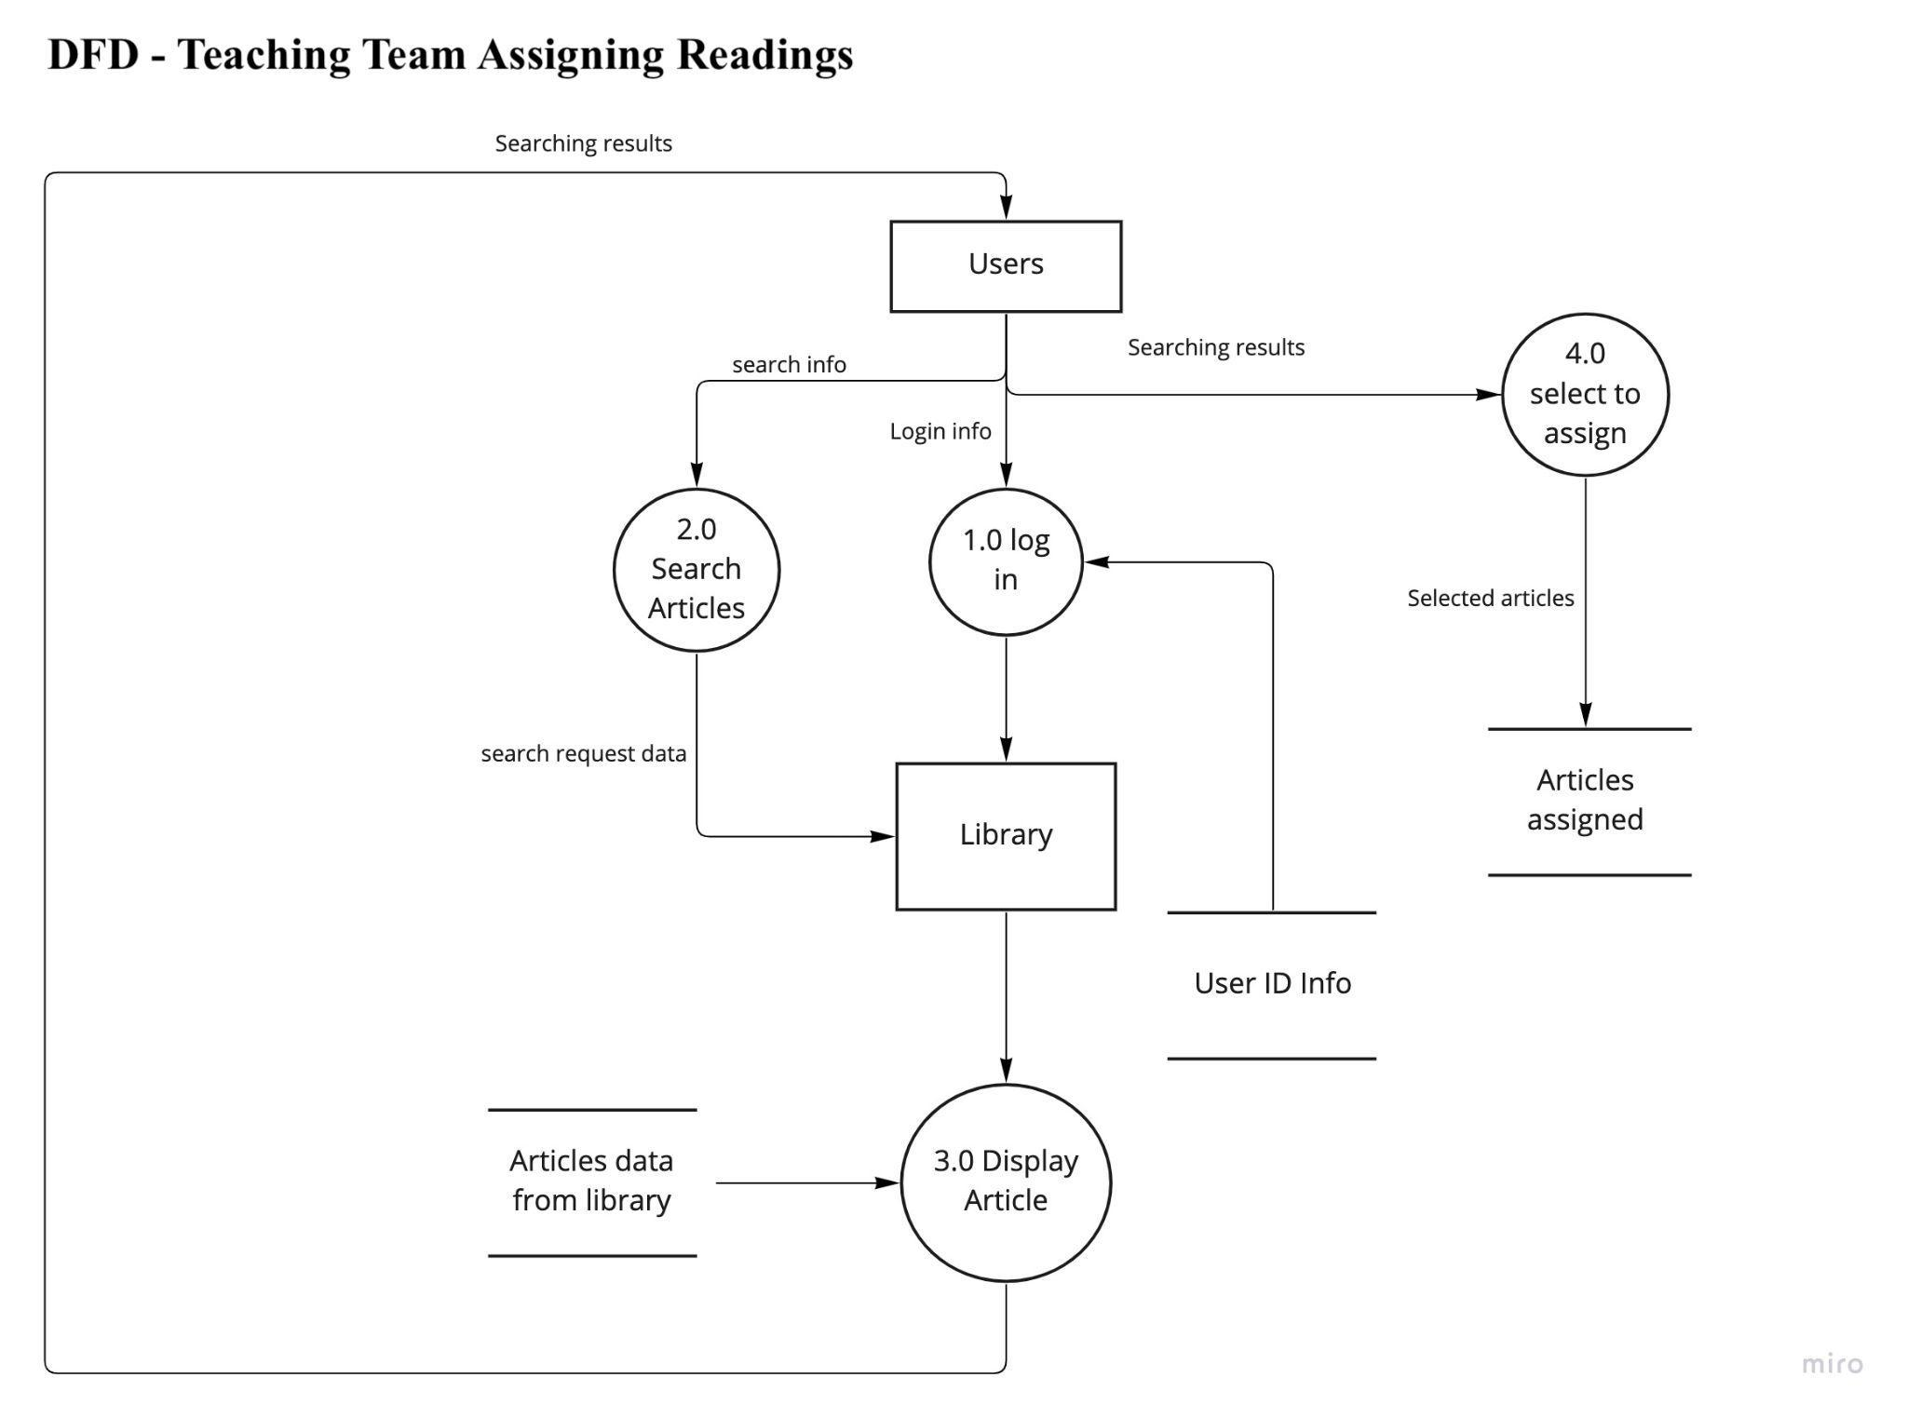

When the teaching team needs to assign any reading to students, the same login process is required, as shown in Figure 7. The teaching team needs to search the articles from the existing library database and assign the article to students in certain classes. The article assigned will be stored in the “Articles assigned” database.

**Figure 8**

*DFD-Teaching Team Managing Assigned Reading*

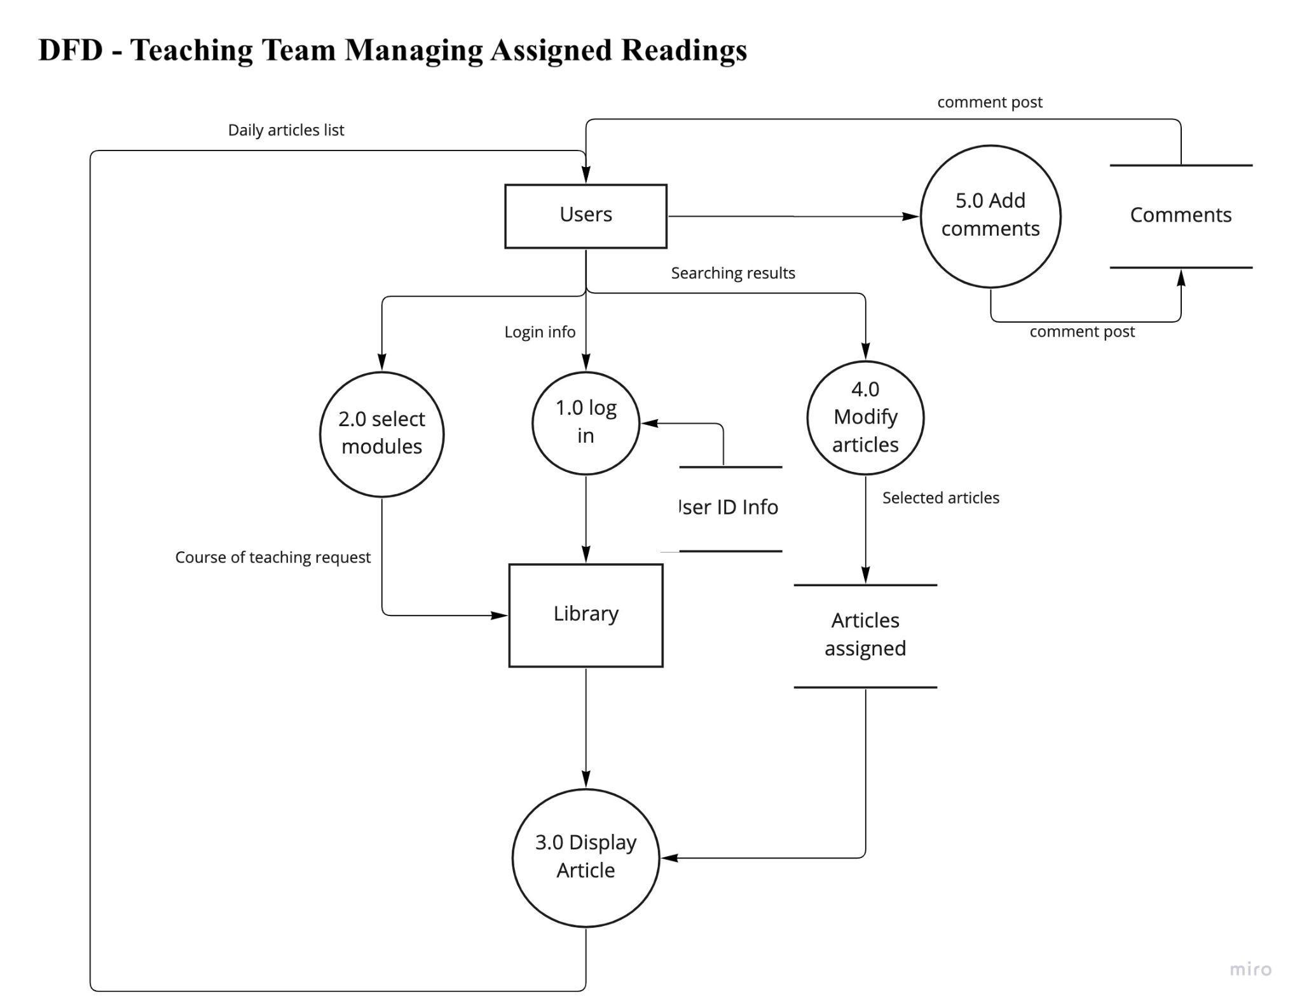

The Solibrary system will pull the articles from the “Articles assigned” database when the teaching team wants to modify the setting, such as deleting the articles from the reading list for students or changing the articles. The teaching team can also add comments to these articles to answer any questions from students or post any announcements related to the articles.

# 

# **Logical design of process**

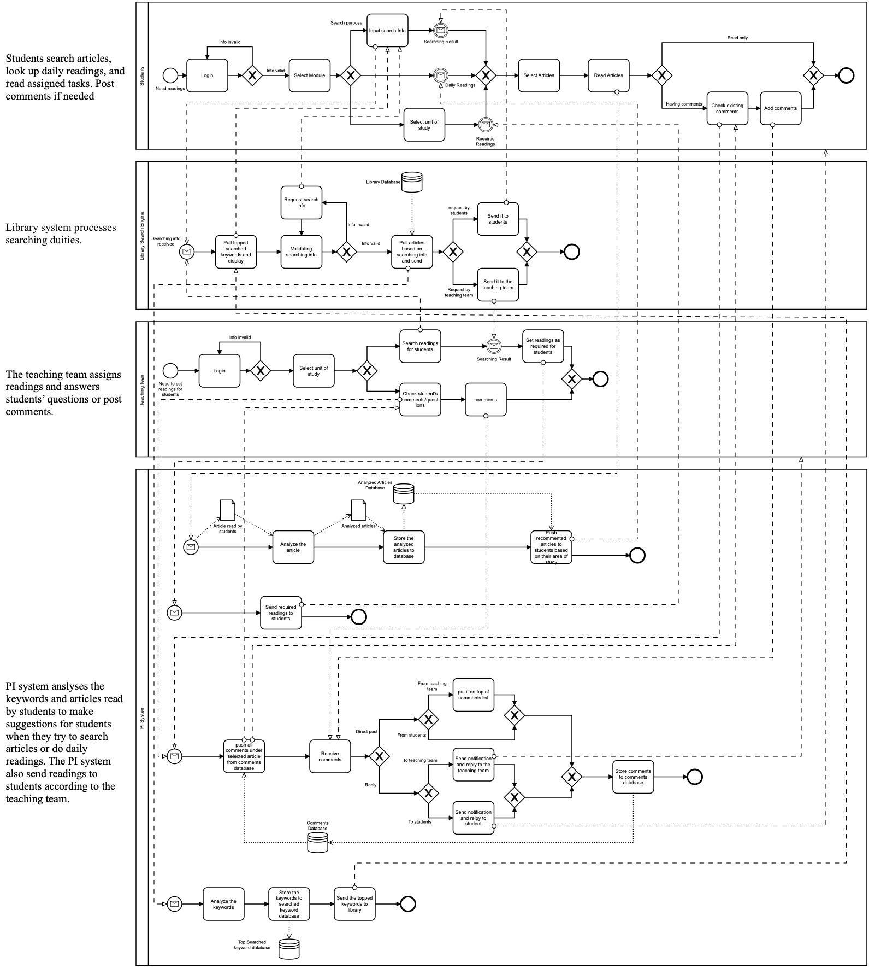

# **Interface**

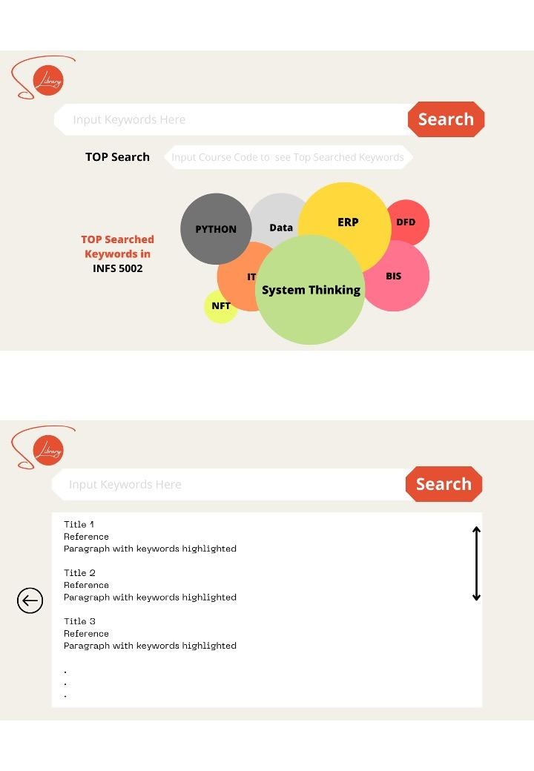

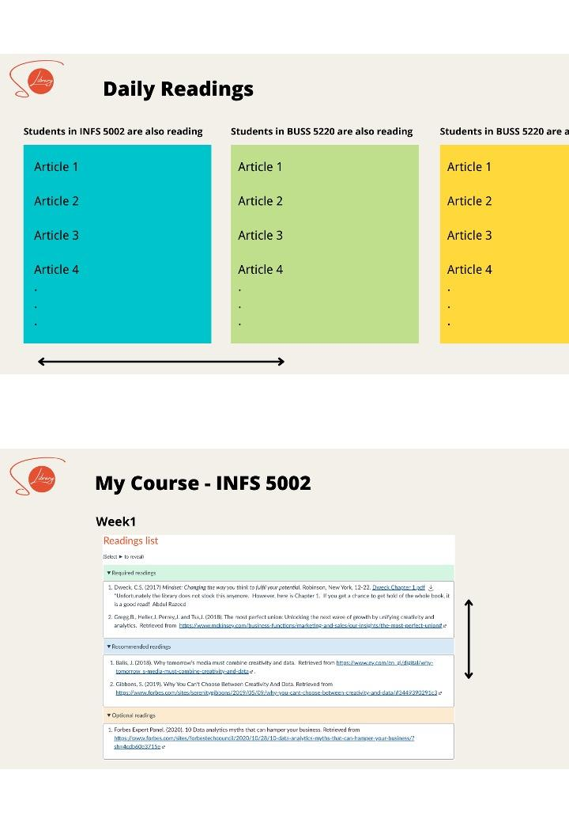

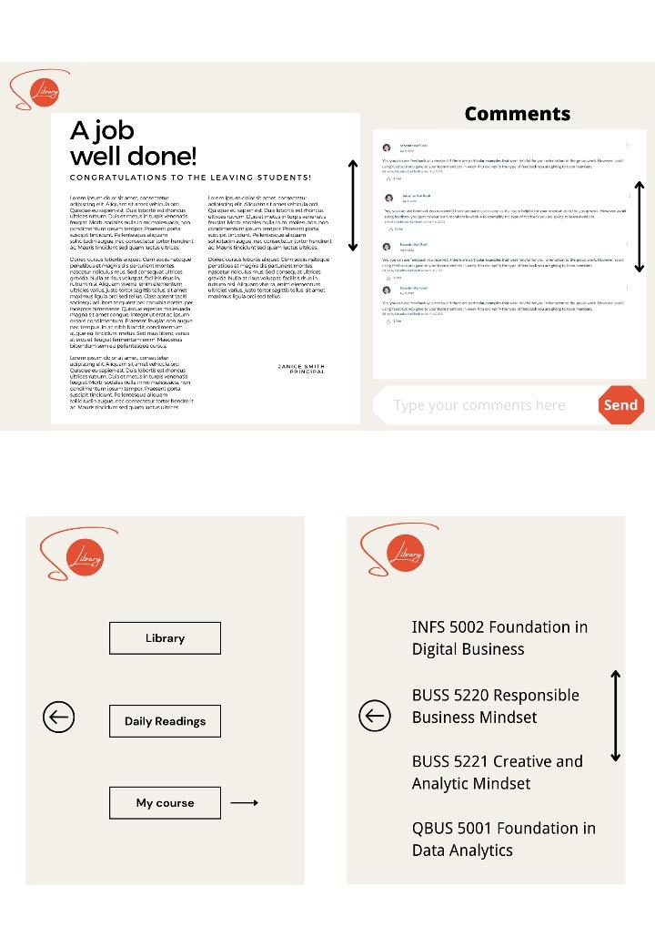

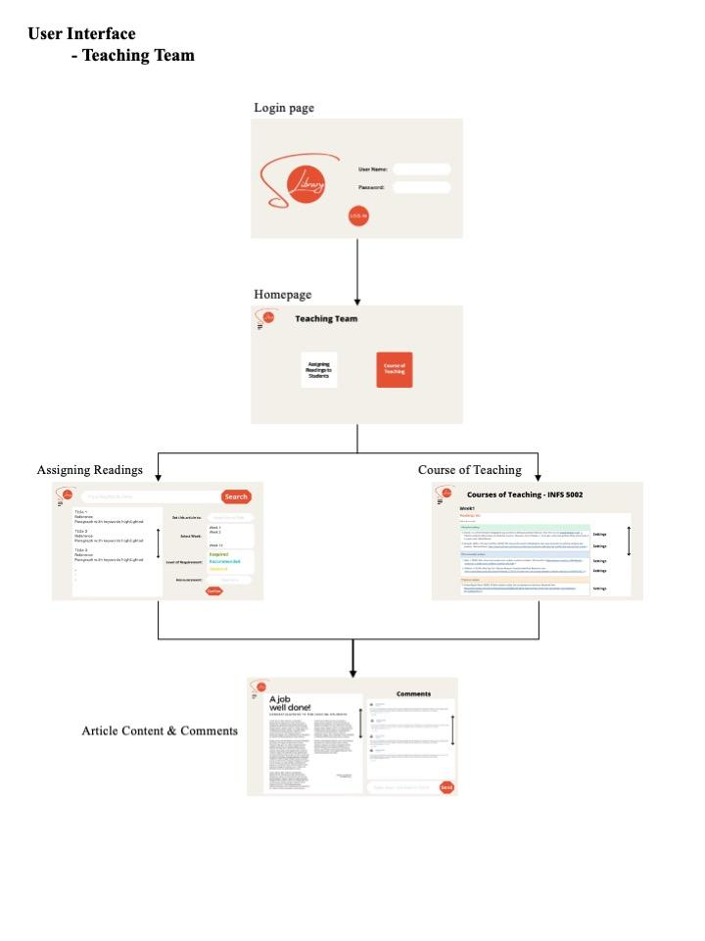

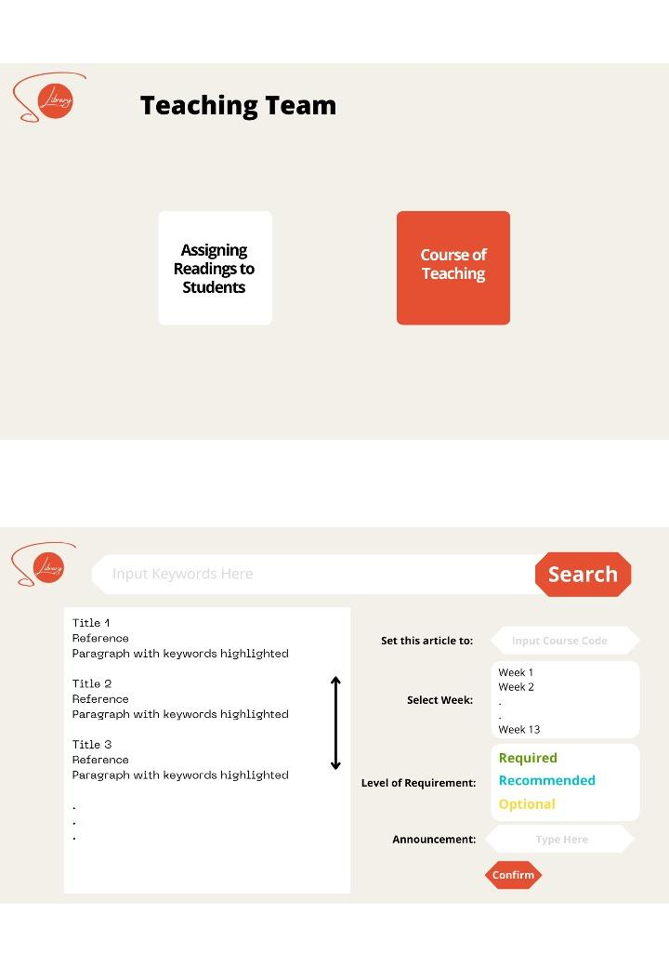

# **Implementation and Costing**

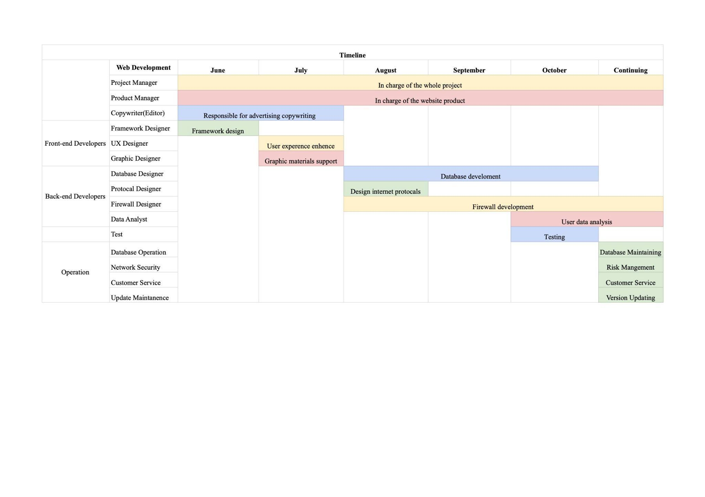

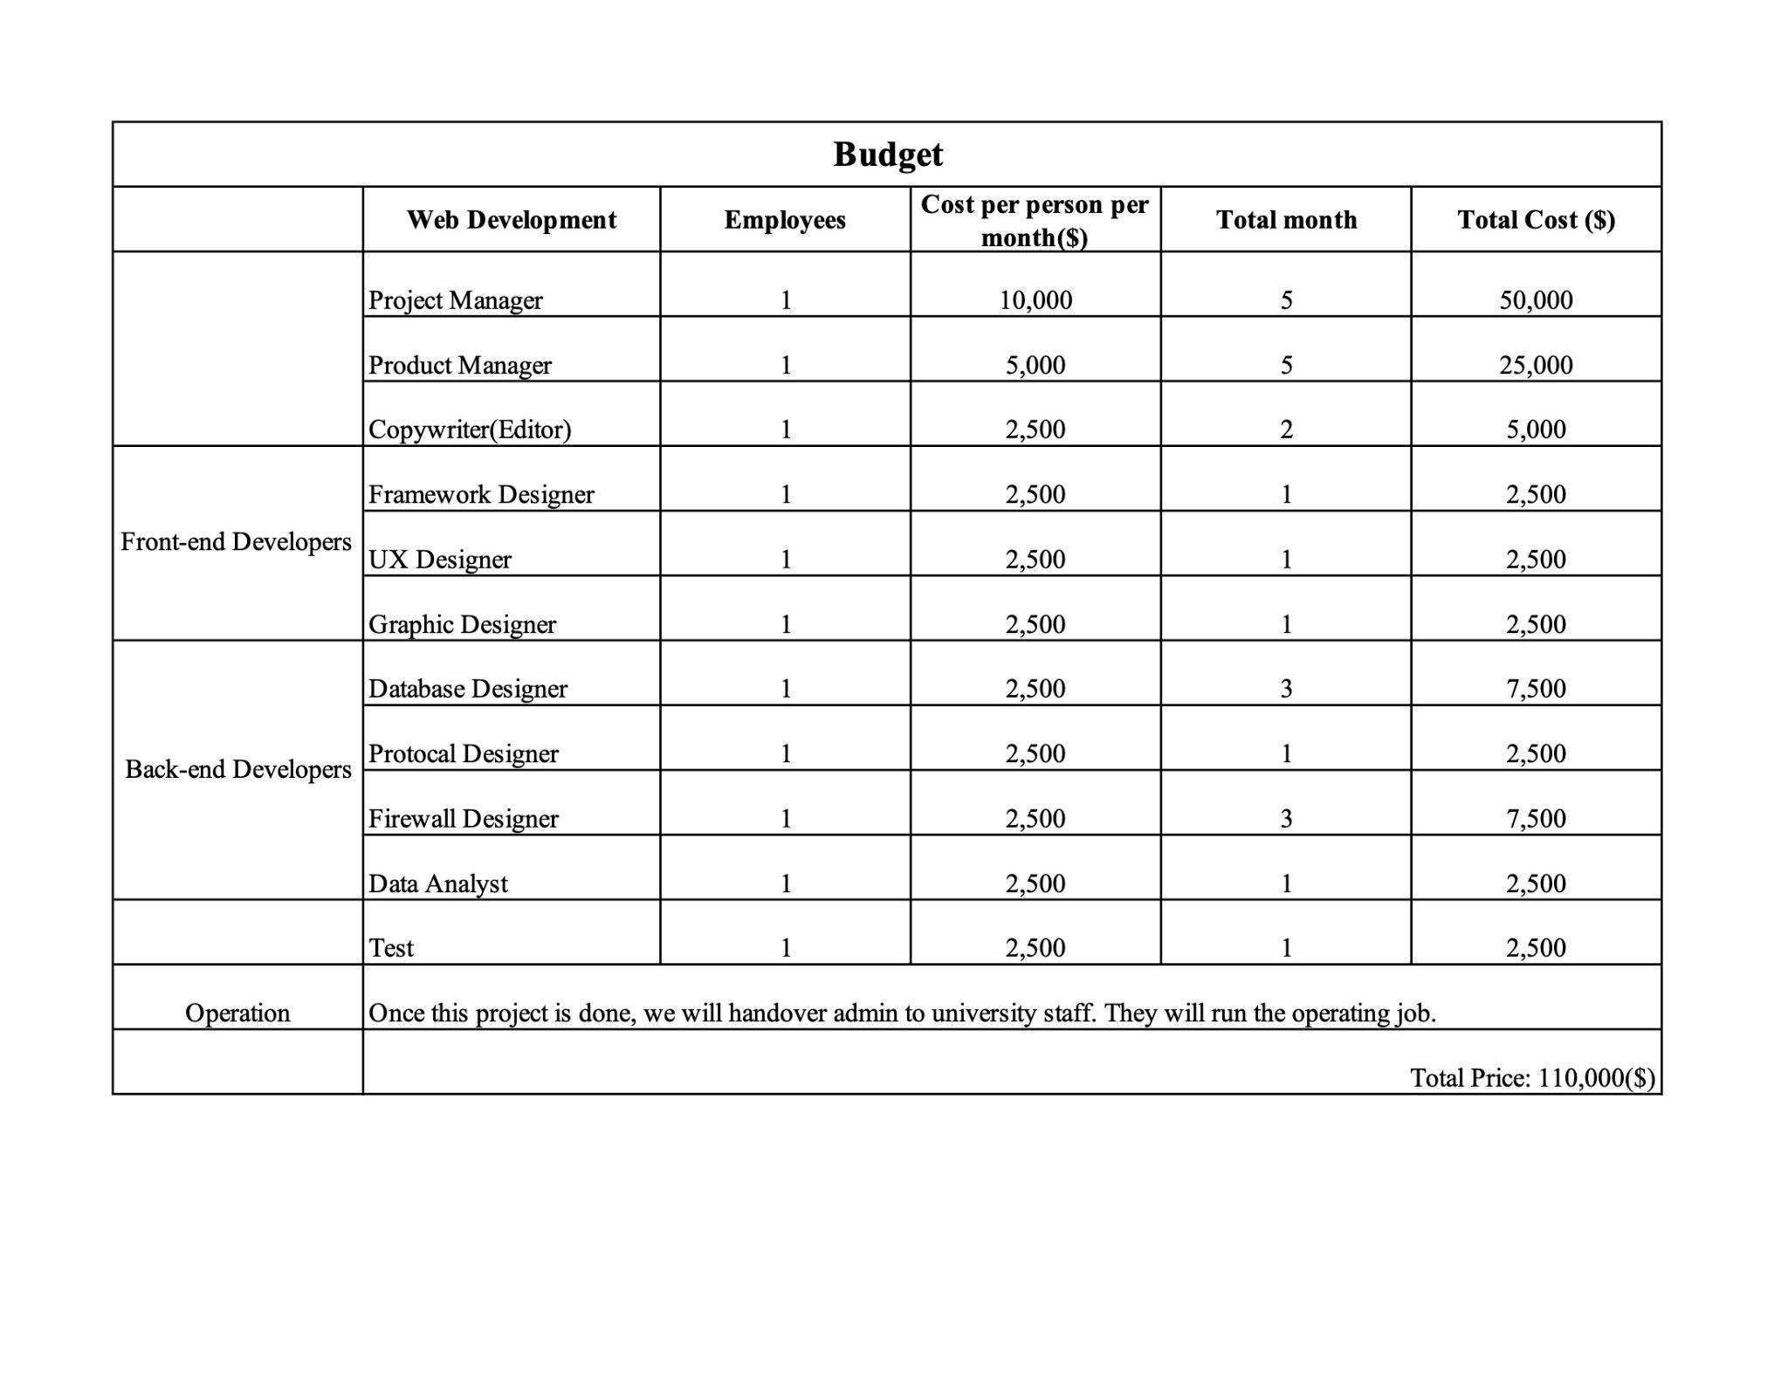

# 

# **Evaluation**

The newly designed system with cutting-edge features-big data push function and latest data oriented algorithm will solve all the pain points we mentioned above. By analyzing the top searched keywords, SoLibrary system will help students who are just starting to learn the course and do not have sufficient knowledge to effectively conduct research. Moreover, by analyzing the students' reading patterns, SoLibrary system can provide students with a better path to acquire more quality literature through their peers via the library system. With the comment function and pushing daily readings, SoLibrary creates a peer-to-peer learning environment through the library system.

In order to perform well on cost control, a “half outsourcing + half in-housing” mode could be considered. The University of Sydney has a lot of excellent students who can work on graphic design, Algorithm design, even part of the back-end development. These are also very good sources of assignments and projects.

It is highly suggested to have a trial period for a small group of specific students and teachers. If everything goes well, then introduce the new system to all USYD students and teachers. Selling it as a SaaS product(White Label) to other universities can also be considered.

This product has a lot of potential both from a useful perspective and profitable perspective. Once it is launched, we will collect data and feedback from users to do system optimization from time to time.

# **Reference List**

Bielefeld, K. (2019, May 16). Research series part 1: Why researching is so hard for our students. Research Series Part 1: Why Researching Is So Hard for Our Students. Retrieved March 19, 2022, from <https://blog.mimio.com/research-series-part-1-why-researching-is-so-hard-for-our-students>

TC Market Buzz. (n.d.). Retrieved May 23, 2022, from <https://www.tradingcentral.com/tc-products/tc-market-buzz>